FINAL YEAR TECHNICAL SEMINAR REPORT

Application of Steganography in Variegated Multimedia

Submitted in partial fulfilment of the degree of Bachelor of Technology
Rajasthan Technical University



By

Anuj Soni
(PIET17CS014)

DEPARTMENT OF COMPUTER ENGINEERING
POORNIMA INSTITUTE OF ENGINEERING & TECHNOLOGY, JAIPUR (Academic Year 2020-21)

FINAL YEAR TECHNICAL SEMINAR REPORT

Application of Steganography in Variegated Multimedia

Submitted in partial fulfilment of the degree of Bachelor of Technology
Rajasthan Technical University

By

Anuj Soni
(PIET17CS014)

DEPARTMENT OF COMPUTER ENGINEERING
POORNIMA INSTITUTE OF ENGINEERING & TECHNOLOGY, JAIPUR (Academic Year 2020-21)

RAJASTHAN TECHNICAL UNIVERSITY

POORNIMA INSTITUTE OF ENGINEERING AND TECHNOLOGY, JAIPUR

CERTIFICATE

This is to certify that Final Year Practical Training Seminar Report entitled “Application of Steganography in Variegated Multimedia” has been submitted by Anuj Soni (PIET17CS014) for partial fulfilment of the Degree of Bachelor of Technology of Rajasthan Technical University. It is found satisfactory and approved for submission.

Date:

Dr. Deepak Moud |  | Dr. Dinesh Goyal
Head, |  | Director,
Dept. of CSE |  | PIET, Jaipur
PIET, Jaipur

DECLARATION

I hereby declare that the seminar report entitled “Final Year Technical Seminar " was carried out and written by me under the guidance of “Dr Deepak Moud”, Assistant Professor, Department of Computer Engineering, Poornima Institute of Engineering & Technology, Jaipur. This work has not been previously formed the basis for the award of any degree or diploma or certificate nor has been submitted elsewhere for the award of any degree or diploma.

Place: Jaipur Anuj Soni
Date: PIET17CS014

ACKNOWLEDGEMENT

A project of such a vast coverage cannot be realized without help from numerous sources and people in the organization. I am thankful to Mr. Shashikant Singhi, Chairman, PGC and Dr. Dinesh Goyal, Director, PIET for providing me a platform to carry out such a technical activity successfully.

I am also very grateful to Mr. Deepak Moud (HOD, CSE) for his kind support.

I would like to take this opportunity to show my gratitude towards “Mr. Manish Bhardvaj and Mrs. Megha Gupta, TS who helped me in successful completion of my Final Year Technical Seminar. They have guided, motivated & were source of inspiration for me to carry out the necessary proceedings for the technical to be completed successfully.

I am also grateful to my guide for help and support.

I am thankful to Mr. Deepak Moud (HOD, CSE) for his kind support and providing me expertise of the domain to develop the project.

I am also privileged to have Mr. Manish Bhardvaj and Mrs. Megha Gupta who have flourished me with their valuable facilities without which this work cannot be completed.

I would also like to express my hearts felt appreciation to all of my friends whose direct or indirect suggestions help me to develop this project and to entire team members for their valuable suggestions.

Lastly, thanks to all faculty members of Computer Engineering department for their moral support and guidance.

Submitted by:

Anuj Soni

ABSTRACT

The field of Steganography has taken a dynamic twist in recent times, with the idea of combing the concept with other technologies. Steganography is one of the security techniques working on the concept of obscurity, the process of hiding confidential information between the sender and the intended recipient. Steganography has been popularly known for hiding confidential data in image type dominantly. However, it can be equally fruitful in all other types of files, including digital images, audio, and video.
This worked offers a review of the steganography of different types of media. Various implementations have different requirements of the steganography concept. This practice tends to perform steganography techniques over all types of multimedia. The required effort of providing security on the cloud platforms and other fields comprising data handling and processing asks for more complex and efficient encryption methods and experiments.
With the rise of a huge number of security thefts and data breaches on Cloud Platforms and IoT networks, newer and better encryption standards are the need of this hour for better establishment of the Right to Privacy and Steganography, however, a matured concept in encryption, plays a significant role. Cloud Computing has evolved data security issues that are sensitive to the users. It provides an abandoned source of computer resources and facilitates communication as well. Consequently, a high level of data security is required in order to protect user information.
It is needed that we explore better encryption techniques for all types of multimedia because information uploaded onto any warehouse is required to be safe and secure from any third-party access and any destructive malware. Data security is one of the most sensitive aspects of Cloud Computing. In crucial view of the need for efficient techniques in information hiding from any chance of violation of confidentiality, integrity, and availability, different people have come up with different ideas and concepts of data obscurity. This supports the innovation of different approaches to enhance data security in every field possible.

Keywords -- Multimedia, Data Security, Cryptography, Steganography, Cloud

INDEX

Chapter 1: INTRODUCTION
A. Topic Description xi
B. Literature Review xii

Chapter 2: TECHNOLOGY SPECIFICATION
A. Language Learned xiv
B. Tools xxiii
Chapter 3: METHODOLOGY xxiv

List of Figures

Figure No Title Page
1.1 Information Security 18
1.2 AES Architecture 19
1.3 Steganography 19
1.4 Image Pixel Formation 20
1.5 Image Bit Format – LSB 21

4.1 Encryption in Image 23
4.2 Image Segmentation 24
4.3 Cloud Architecture 25
4.4 Pseudo Code 26
4.5 Result 29

Final Year Technical Report, Academic Year 2020-21, PIET, Jaipur

Chapter 1 – Introduction

  - Steganography
Steganography is that the process of hiding confidential data within a plain, non-secret files to avoid detection; the key data is then deciphered at its destination. The use of steganography is often combined with encryption as an additional step for hiding or protecting data. The word steganography springs from the Greek words steganos (meaning hidden) and therefore the Greek root graph (meaning to write).
Steganography is often wont to conceal almost any sort of digital content, including text, image, video, or audio content; the info to be hidden are often hidden inside almost any other type of digital content. The content to be hidden through steganography -- termed as hidden data -- is typically encoded before being incorporated into the otherwise plain seeming cover data stream. If not encrypted, the hidden text is commonly processed in some way to increase the difficulty of detecting the secret content.
Steganography is taken into consideration by those desiring to convey confidential data. While there are many legitimate uses for steganography, malware developers have also been found to use steganography to obscure the transmission of malicious code.
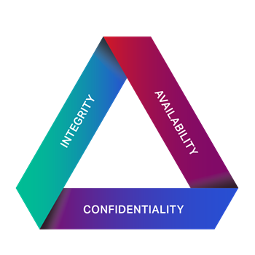
1.1.1 Steganography Techniques
In digital steganography, data is first of all obfuscated in some different pattern and then incorporated, using a particular algorithm, into data that is part of a specific file format such as an image, video, or audio file. The confidential message can be incorporated into ordinary data files in various techniques. One technique is to obscure data in bits that represent the same color pixels repeated in a row in an image file. By applying the encoded data to this repeating data in some inconspicuous way, the result will be an image file that seems identical to the original image but that has "noise" patterns of plain, unencrypted data.

Final Year Technical Report, Academic Year 2020-21, PIET, Jaipur
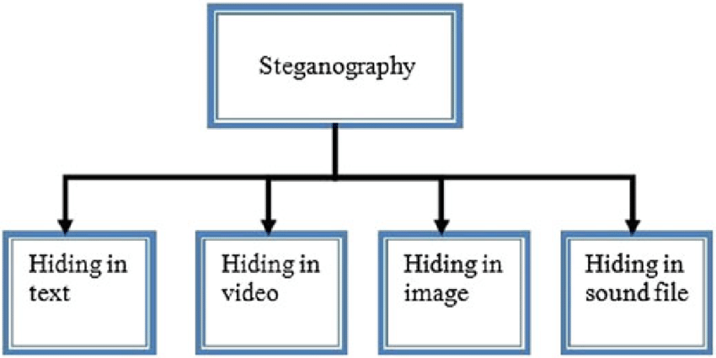
The practice of having a watermark -- a trademark hidden in multimedia -- is one simple use of steganography. Watermarking is a technique which is often used by publishers to detect the media file sources that have been found being distributed without permission. Embedding sensitive information into different file type is one of the common techniques to embed a text file into an image.
1.1.2 Advanced Encryption Standards
AES is the most popularly adopted symmetric key encryption standard proposed to date. It is said to be at least six times efficient than triple DES. The features of AES are -
- Symmetric key block cipher
- 128-bit data, 128/192/256-bit keys
- Stronger and efficient than Triple-DES
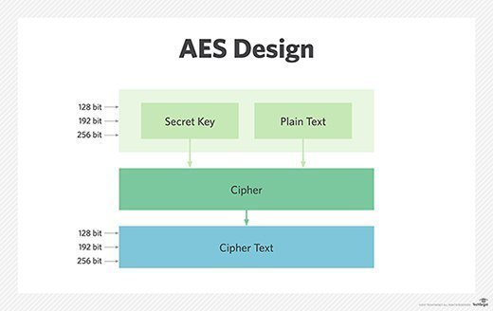

Final Year Technical Report, Academic Year 2020-21, PIET, Jaipur

1.1.3 Image Pixel Formation
Pixel is the atom element of an image. Images are represented in a grid-like structure in which the pixels come at the place of a cell. Each pixel retains one numeric value which depends on the image type and format. In an 8-bit grayscale image, the value of the pixel ranges between (0, 255). The pixel value at some point relates to the intensity of the light photons striking at that point. Each pixel value is proportional to the light intensity at that particular coordinate.
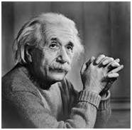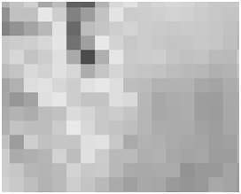

1.1.4 Least Significant Bit - LSB
Pixels are portrayed in the format of the bits and each bit retains some data about the tone of pixel color.
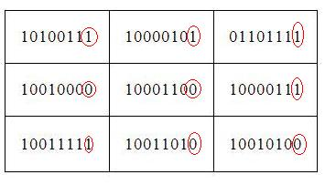
The number of bits used to store the information in each pixel is termed as Bit Depth, and it directly affects the resolution of image. Bit depth also corresponds to bit rate & file size.
1 bit (2¹⁾ = 2 tones  2 bits (2²) = 4 tones  3 bits (2³⁾ = 8 tones  4 bits (2⁴⁾ = 16 tones | 8 bits (2⁸) = 256 tones  16 bits (2¹⁶⁾ = 65,536 tones  24 bits (2²⁴⁾ = 16.7 million tones

Final Year Technical Report, Academic Year 2020-21, PIET, Jaipur

  - Literature Review
- Jacob Adeboye Ajala, Sanika Singh, Saurabh Mukherjee, & Sudeshna Chakraborty have implemented the “Applications of Steganography Techniques in Cloud Computing” and published their work under IEEE in 2019. The approach they used was chunking of image files for recipient and decryption of images at the receiver side by file recombination techniques. The experiments had successful results; however, accuracies are to be worked upon.
- Surbhi Singla & Anju Bala have showcased their work by the title “Cryptography & Steganography Algorithms for Cloud Computing” published under IEEE in 2018. The paper implemented a combination of Cryptography and Steganography algorithms to achieve data security over Cloud Platforms. The experiment concluded with a future scope of better algorithms for User node authentication for “Man-in-the-Middle” detection.
- B. Fathima Mary & D. I. George Amalarethinam published their experiment in the paper by the name “Data Security Enhancement in Public Cloud Storage using Data Obfuscation & Steganography” under IEEE in 2017. The paper contained the MRADO technique to improve the classical obfuscation techniques by integrating substitution and transposition with ASCII values. The experiment was conducted on text type data only, so that leaves a scope for other multimedia.

    - Challenges & Gaps
- Chunking of file to store them on Cloud servers is a better approach but the mechanism is to be made more complex so as to make sure the decryption process for the intruder can be made difficult.
- Studies have shown that using cryptography along with steganography is a considerable approach but the limitation of “Man-in-the-Middle” detection is apparent. Asymmetric Key encryption can be implemented to detect the intruder by the use of private and public key concept.
- The MRADO technique for data obfuscation is a unique approach but the experiment was performed only on text-type data. We will see if the same technique can be implemented on multimedia data.

Final Year Technical Report, Academic Year 2020-21, PIET, Jaipur

Chapter 2 – Technology Specification
2.1 Programming Language – Python 3.9
Python is an interpreted, object-oriented, high-level programming language with dynamic semantics. Its high-level built in data structures, combined with dynamic typing and dynamic binding; make it very attractive for Rapid Application Development (RAD), as well as for use as a scripting or glue language to connect existing components together.

Python is an extremely useful programming language for cyber-security professionals because it can perform a multitude of cyber-security functions, including malware analysis, scanning, and penetration testing tasks.
2.1.1 Features in Python
- Free and Open Source
- Object-Oriented Language
- GUI Programming Support
- Extensible & Portable
- Integrated language

2.2 Tool – Jupyter Notebook

Jupyter Notebook is an open-source web application that allows you to create and share documents that contain live code, equations, visualizations and narrative text. Uses include: data cleaning and transformation, numerical simulation, statistical modeling, data visualization, machine learning, and much more.

Final Year Technical Report, Academic Year 2020-21, PIET, Jaipur

Chapter 3 – Methodology
  - Encryption in Images
As the terminology goes, Image Steganography stands for the process of obscuring data inside an image format file. The image so used for encrypting data, which works as the carrier is termed as the cover image, and the image achieved as output after performing steganography is called the stego-image.

An image is conceptually represented as an N*M matrix in greyscale images and N*M*3 matrix in color images in the system, in which each entry at the coordinate position represents the pixel intensity. In image steganography, a message is embedded into an image by modifying the values of the targeted pixels, which are selected according to an encryption algorithm. The authorized receiver of the image must be aware of the exact algorithm to know which pixels must be selected to decipher the desired message.

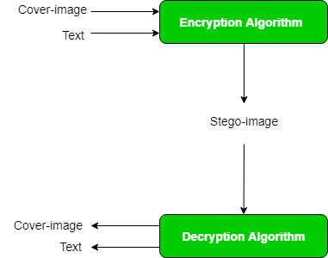

The deciphering of the desiring message within the carrier or cover-image is performed by the process of “Steganalysis”. This can be achieved through comparison with the cover image, histogram plotting, or noise detection. While efforts are being invested in developing new algorithms with a greater degree of immunity against such attacks, efforts are also being devoted towards improving existing algorithms for “Steganalysis”, to detect the exchange of secret information between terrorists or criminal elements.

  - Image Segmentation & Slicing
Image segmentation is the technique of dividing a digital image into multiple segments or parts (sets of pixels, a.k.a. image objects). Segmentation aims to make a simple presentation of an image into something extra meaningful and easy to analyze. Image segmentation is generally used to detect objects and boundaries (curves, lines, etc.) in images. Precisely, image segmentation is the technique of assigning a label to each pixel in an image so that pixels with the same label share certain characteristics.

Final Year Technical Report, Academic Year 2020-21, PIET, Jaipur

The results of image segmentation may be a set of segments that covers the whole image or a group of contours extricated from the image. Each pixel found in the region is analogous with reference to some characteristic or property, like color, texture, or intensity. Adjacent regions are significantly varying with reference to a similar characteristic(s). When applied to a stack of images, typical in medical imaging, the resulting contours after image segmentation are often wont to create 3D reconstructions with the assistance of interpolation algorithms like marching cubes.

    - Groups of Image Segmentation
- Semantic segmentation is an approach classifying, for every pixel, the belonging object class. For example, when all people in a figure are segmented as separate objects and background as one object.
- Instance segmentation is an approach to detect, for every pixel, a belonging object instance. It recognizes each different object of interest in the image. For example, when everyone during a figure is segmented as a private object.
Image Slicing:
Slicing is the process of partitioning an image into logical sub-images. When you slice a picture, you divide it into several smaller images that you simply can save in several formats or at different levels of optimization. Slicing a stego-image and saving the sliced image on Cloud in different formats may increase the complexity of the Steganographic System.

  - Cloud Architecture
Cloud Architecture contains varied components in terms of databases, software capabilities, applications, etc. engineered to leverage the facility of cloud resources to unravel business problems. Cloud architecture defines the components along with the relationships between them.
The various components of Cloud Architecture are:
- Cloud Resources
- On-premise Resources
- Software Services and Components
- Middleware
The entire cloud architecture is ideally supposed to provide the users with high bandwidth, uninterrupted access to data servers and applications, and on-demand agile network with efficient movement between servers or even between different clouds, and prominently network security. The various cloud-based services have their own corresponding cloud architectures:

Final Year Technical Report, Academic Year 2020-21, PIET, Jaipur
- Software as a Service (SaaS) provides software hosted and managed on internet servers. With SaaS, users have the availability to use the software virtually without dependence on the hardware system specification.
- Development as a Service (DaaS) provides web-based development tools distributed among different communities.
- Platform as a Service (PaaS) involves users with databases and application platforms, similar to middleware services.
- Infrastructure as a Service (IaaS) involves services for hardware infrastructure such as servers, networks, storage devices, etc. running onto the cloud, available to users against a pay per usage basis.
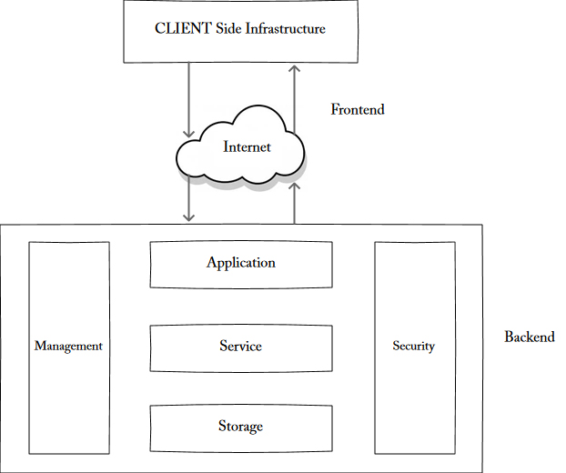
3.4 Pseudo Code
To achieve our goal we are going to combine all the concepts that we have discussed so far. First off with AES Encryption on Text:
- AES Mode
- Padding
- Key
- Block Cipher
- Hashing

Final Year Technical Report, Academic Year 2020-21, PIET, Jaipur
.
Procedure:
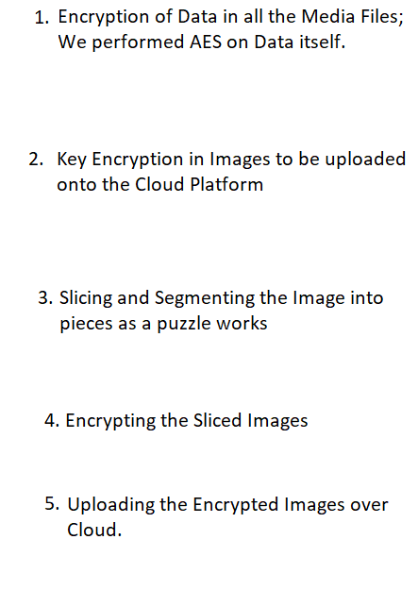
AES ALGORITHM:
State = M
AddRoundKey(state, &w[0])
For i = 1 at step 1 till 9
SubBytes(state)
ShiftRows(state)
MixColumns(state)
AddRoundKey(state, &w[i*4])
End for
SubBytes(state)
ShiftRows(state)
AddRoundKey(state, &w[40])

Final Year Technical Report, Academic Year 2020-21, PIET, Jaipur

Audio Encryption:
- Obtain Audio File - WAV File Format for High Quality PCM Audio Data.
- Initialize source audio file.
- Get data from source audio file as a string of bytes.
- Convert data into list of readable integer ordinal format.
- Initialize text message to be embedded.
- Hide text message into the list order data.
- 1 frame = 4 bytes; pack order data to hex and write byte by byte.
- Gets non-readable data from the source wave file.
- Return all the wave parameters as a tuple (immutable).
- Get output file path.
- Write new embedded data into a new file (filename given earlier).

Note – When encrypting into images, the following steps should be considered:
- Open an image and observe the pixel in hexadecimal.
- If the pixels blue channel falls in the 0-5 range then 1 bit of information is stored.
- End the stream with a delimiter of 15 1’s and 0’s to take up 2 bytes.
- When time is to retrieve it pull all the blue bits of 0 and 1 until the stream obtains the delimiter of fifteen 1’s and 0’s.
- User-defined data manipulating functions include rgb2hex(), hex2rgb(), str2bin(), and bin2str().
- The operations will include hiding, retrieving, encoding, and decoding, which will form the methods.

  - Results:
We have successfully implemented the steganography over text type data, images data, and audio files. We have also performed AES encryption on the Text Data and Image Slicing using Python as the coding language.

Final Year Technical Report, Academic Year 2020-21, PIET, Jaipur

Steganography is useful for hiding messages for transmission. One of the main discoveries of this investigation was that every steganographic implementation carries with it significant trade-off decisions, and it's up to the steganographer to make a decision which implementation suits him/her the best.

  - Future Work:

Since we have covered a small part on steganography, a lot of work is left out. We will be working on video steganography and asymmetric key encryption. Concluding the work, we find that although steganography is not a new concept, still it thrives for more complex encryption system and as we will see advancement in Cryptographic standards, new updates will also be seen in Steganographic system.

REFERENCES

- Jacob Adeboye Ajala, Sanika Singh, Saurabh Mukherjee, & Sudeshna Chakraborty have implemented the “Applications of Steganography Techniques in Cloud Computing” and published their work under IEEE in 2019. The approach they used was chunking of image files for recipient and decryption of images at the receiver side by file recombination techniques.

- Surbhi Singla & Anju Bala have showcased their work by the title “Cryptography & Steganography Algorithms for Cloud Computing” published under IEEE in 2018. The paper implemented a combination of Cryptography and Steganography algorithms to achieve data security over Cloud Platforms.

- B. Fathima Mary & D. I. George Amalarethinam published their experiment in the paper by the name “Data Security Enhancement in Public Cloud Storage using Data Obfuscation & Steganography” under IEEE in 2017. The paper contained the MRADO technique to improve the classical obfuscation techniques by integrating substitution and transposition with ASCII values.

